## What makes a good coach?

An objective is a written statement of intent that clearly describes what actions or tasks, with measurable end results, an individual, team or organisation wants to achieve within a specified time period.

They can be “hard” in the sense that something quantifiable is to be achieved. A 10% increase in student numbers on xx degree programme or “soft” in the sense that they are difficult to attach a number to. Descriptions are often the best way of setting soft objectives. You may also have objectives related to developing skills or knowledge. I.e. John is to attend an advanced excel training course by Sept 09 to enable him to use macro commands to speed up data analysis in xx dept.

**Why have objectives?**

* Give direction to an individual’s work
* Make clear what tasks individual are expected to focus on
* Make clear standards to which individuals are expected to perform in their role
* Clarify priorities and the relative importance of tasks and activities
* Clarify the purpose of the role and its place and contribution within the team or dept
* Provide an opportunity to think systematically about all aspects of the job and performance in those aspects
* Provide a basis for discussing how people are doing
* Provide an agenda for professional & personal development.

Objectives provide the focus for coaching conversations. The “SMARTer” the objectives the sharper the focus of the coaching conversation.

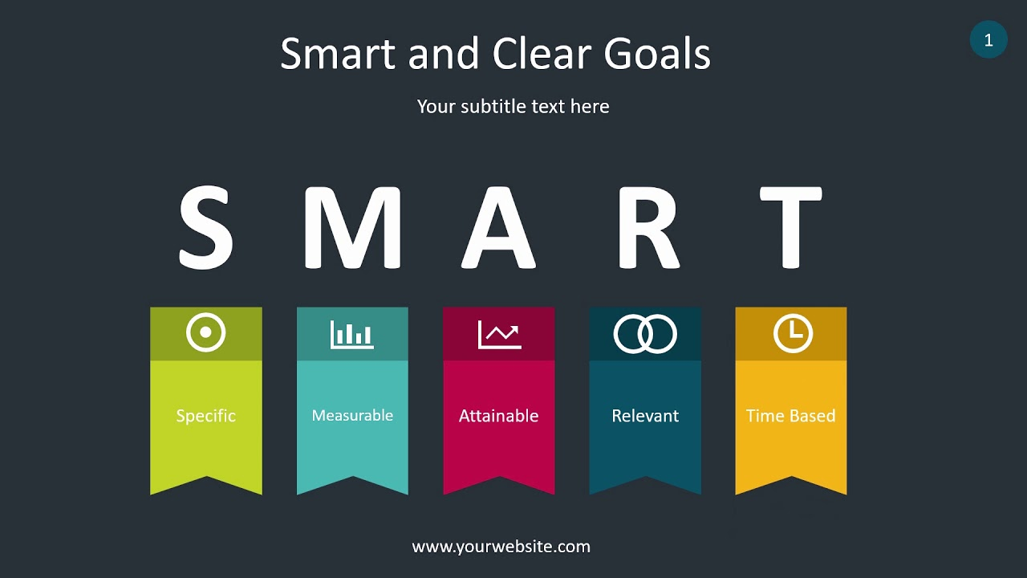**SMART Objectives**

An objective should be:

● Specific

● Measurable

● Achievable

● Relevant

● Time­constrained